**Spam Classifier**

**Project Report**

**By: Group # 3**

**Kainat Zahra 183159**

**Momina Iqbal 183173**

**Furqan Amjad 183205**

**Anas Malik 183183**

**Introduction :**

* Spamming is one of the major attacks that accumulate a large number of compromised machines by sending unwanted messages.
* In this project we have designed a spam classifier app that prevents the spam messages from getting into the user's inbox.
* The objective is to classify the sender as spammer or non-spammer by applying various checks on his/her email address, Ip-address or the words being sent.

**Objective :**

* Spamming is one of the major attacks that accumulate a large number of compromised machines by sending unwanted messages.
* In this project we have designed a spam classifier app that prevents the spam messages from getting into the user's inbox.
* The objective is to classify the sender as spammer or non-spammer by applying various checks on his/her email address, Ip-address or the words being sent

**Project milestone 1:**

* A complete project report was made and submitted on time.
* The project report contains all the required details like:
* Introduction
* Problem Statement
* Solution
* Project goals and objectives
* Project scope

**Project milestone 2:**

* We have completed the (a) part of our web application.
* All the apps were registered for the backend.
* The two main apps being used in the backend are:
* Basic contact app
* Spam Classifier app
* Super user was created to access admin interface
* Models were defined so that the data can be stored on the database.

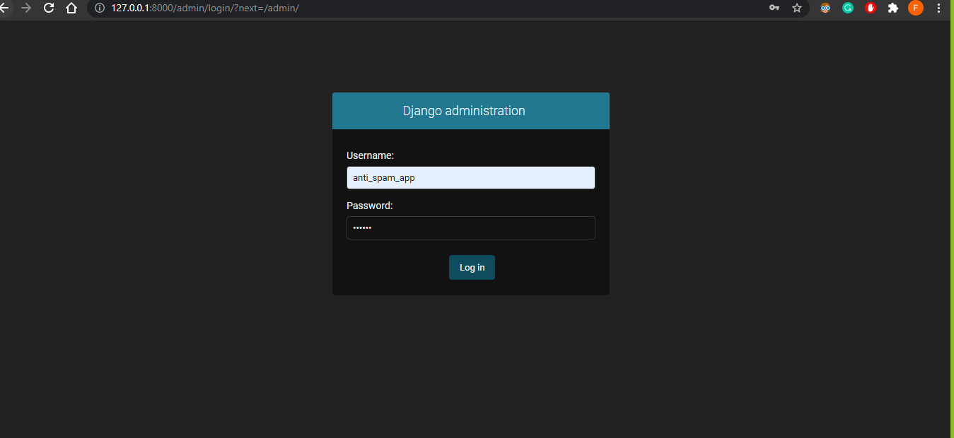

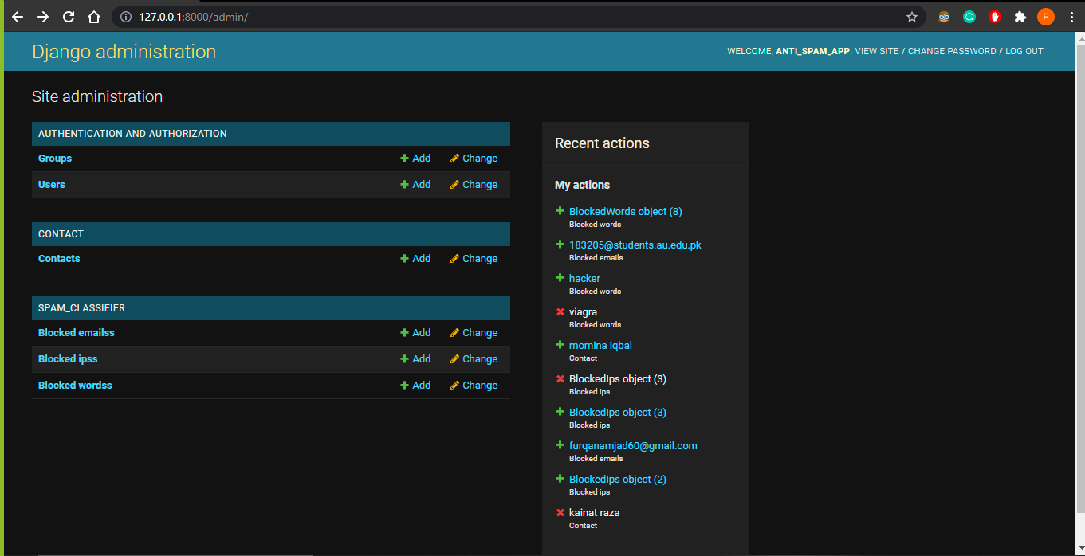

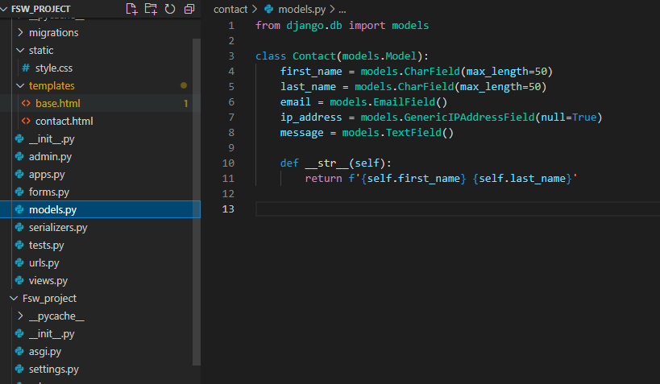

**Project milestone 3:**

By this milestone:

* We had created an API using the Django REST framework
* Serializers were created to convert model instances to JSON so that the frontend can work with the received data.
* Views were created
* The app was made to perform the basic CRUD activity.
* All the required templates and files were created i.e html files,utils.py,serializers.py and forms.py etc

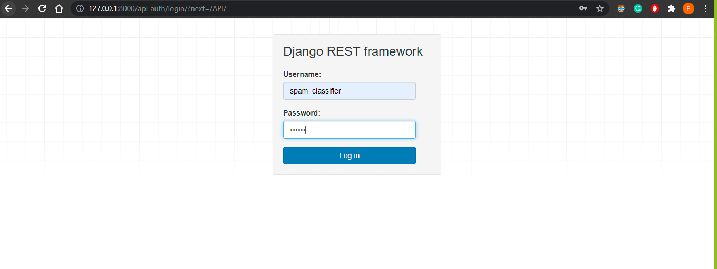

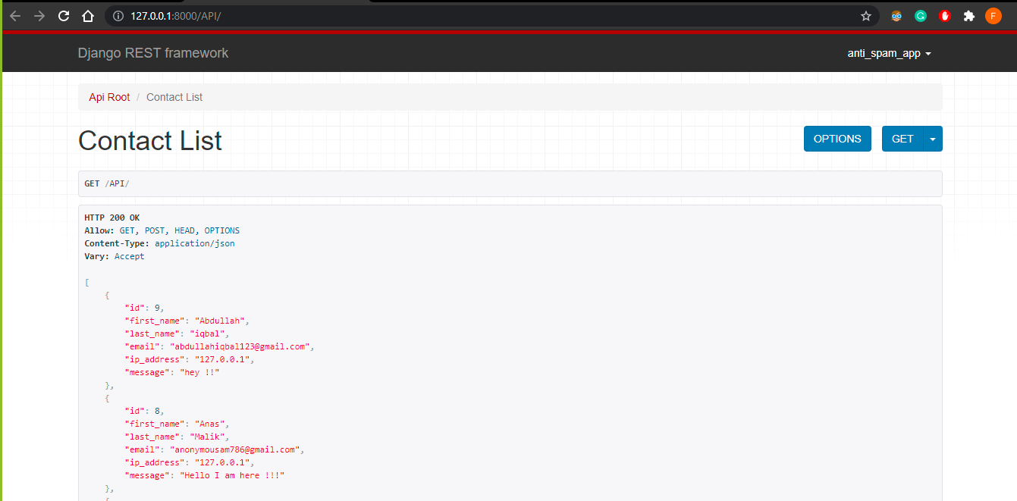

**Project milestone 4:**

By this milestone:

* We had created an API using the Django REST framework
* Serializers were created to convert model instances to JSON so that the frontend can work with the received data.
* Views were created
* The app was made to perform the basic CRUD activity.
* All the required templates and files were created i.e html files,utils.py,serializers.py and forms.py etc

**Our App**

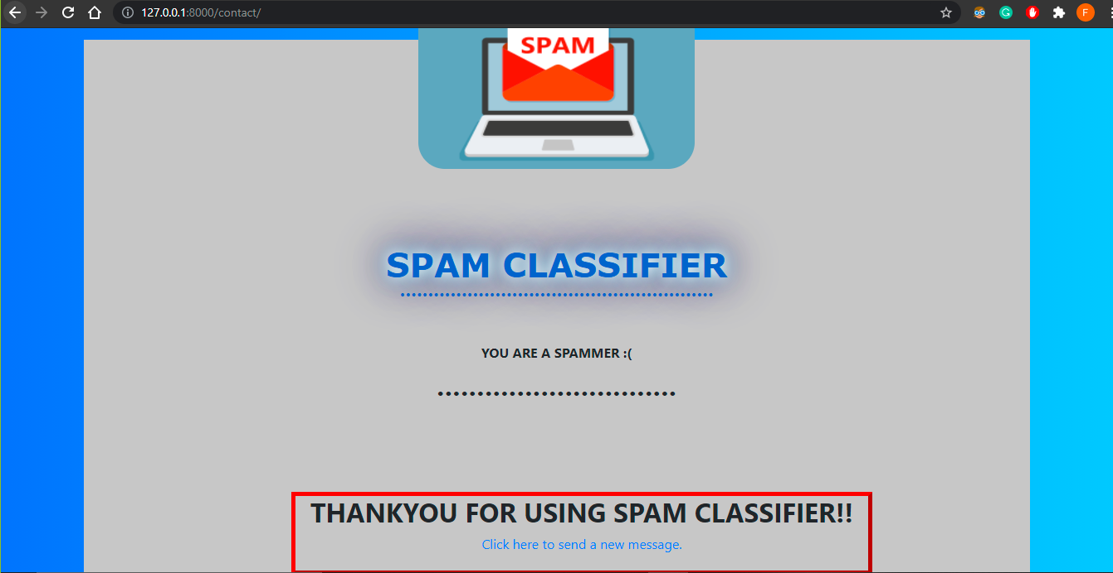

**System Architecture and Wireframes :**

**Flow Chart :**

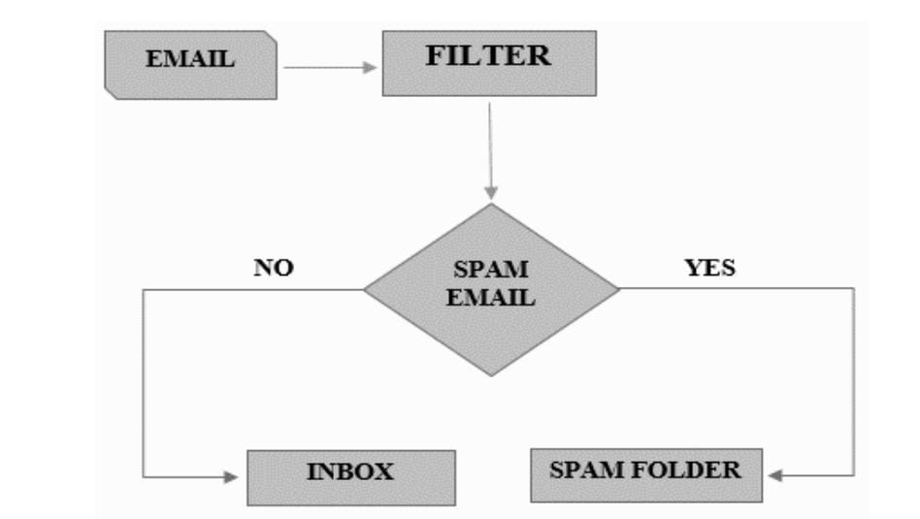

**Use Case Diagram**

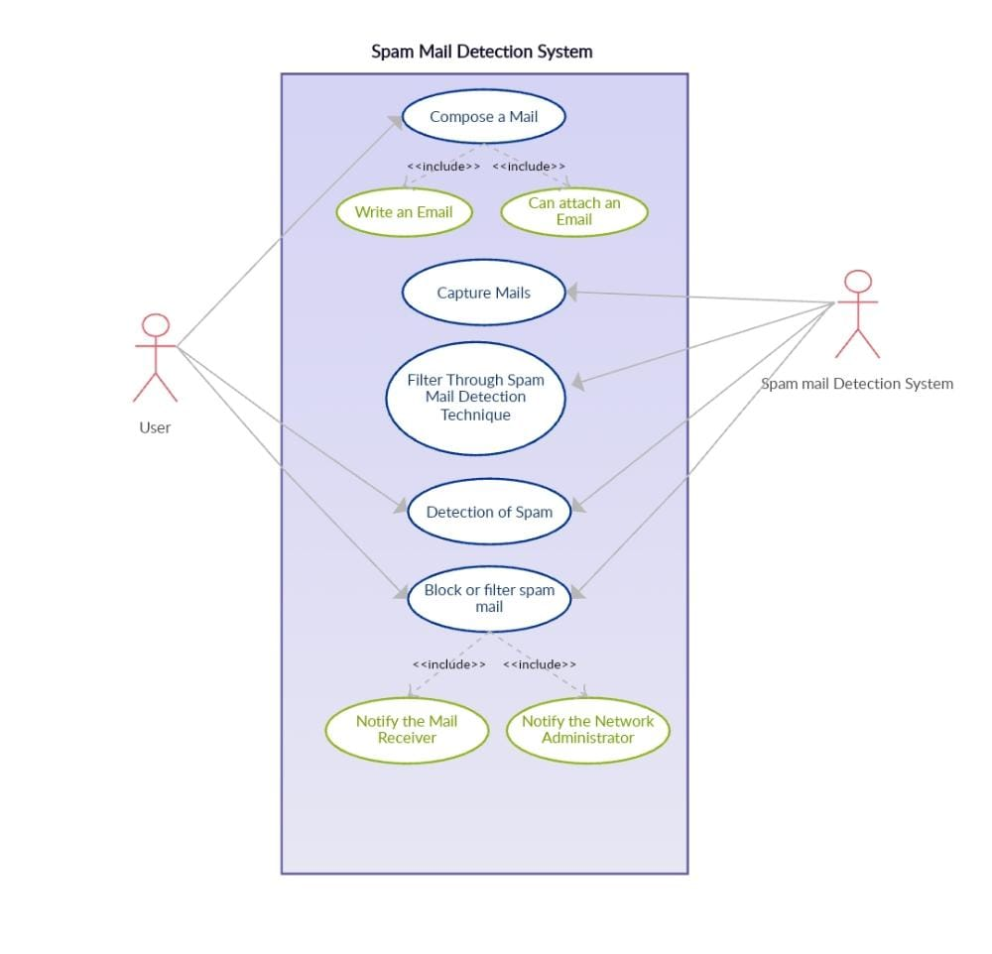

**Data Flow Diagram**

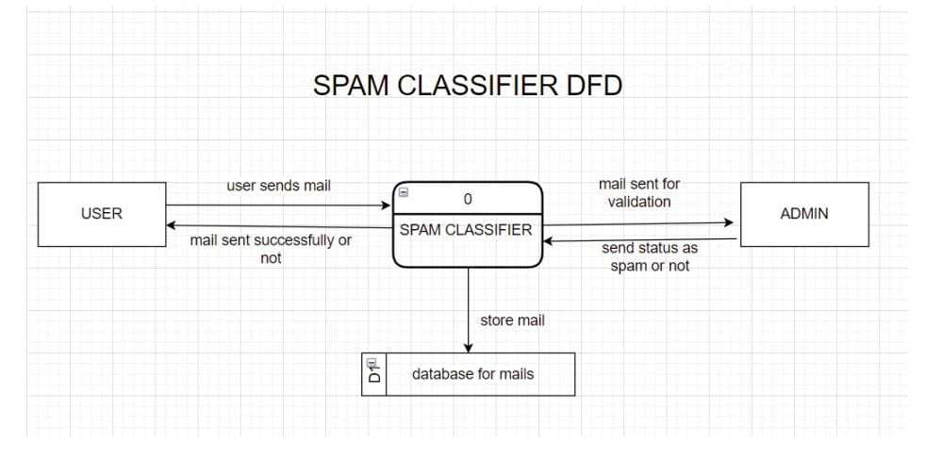

**CONCLUSION :**

Therefore, our spam classifier is successfully detecting the spam mails based on the words, Ips and emails blocked by the admin.